Class 7-week 3 homework

My nickname: Bugs

Desired income: 100k + a month

Group leader’s name: Whalid

Happy Places

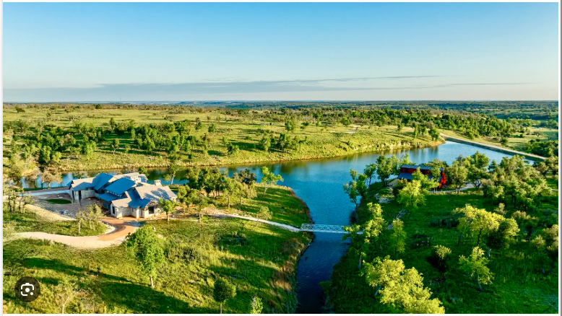

Hobby: Gun range

Week 3 [***https://killercoda.com/pawelpiwosz/course/linuxFundamentals***](https://killercoda.com/pawelpiwosz/course/linuxFundamentals) ***Lessons 1- 10***

